**ATAR HUMAN BIOLOGY – UNIT 1**

**TASK 6 – Digestive, Excretory & Musculoskeletal systems test**

**NAME: _________________________________ WEIGHTING: 5%**

**MARK: ______ /50 = _____ %**

Important Information for Students

1. There are THREE sections in this test - Multiple Choice, Short Answer and Extended Answer.
2. This is a closed-book assessment (no notes are allowed)
3. The time allowed to complete the test is 55 minutes.
4. Write your answers to the Multiple Choice section on the **separate** answer sheet provided.
5. Write your answers to the Short Answer section in space provided.
6. Write your answers to the Extended Answer section in space provided.

|  |  |  |
| --- | --- | --- |
| Sections | **Marks Allocation** | **Your Total** |
| **A - Multiple Choice** | 10 |  |
| **B - Short Answer** | 34 |  |
| **C - Extended Answer** | 6 |  |
| **TOTAL** | 50 |  |

**ATAR HUMAN BIOLOGY UNIT 1**

**Multiple Choice Answer Sheet**

**Name: _____________________________**

**Use a ball point or ink pen to mark an X** on the letter that represents the best answer from the choice of answers. If you make a mistake circle it and then cross the correct answer.

1. A B C D 6. A B C D

2. A B C D 7. A B C D

3. A B C D 8. A B C D

4. A B C D 9. A B C D

5. A B C D 10. A B C D

**Multi Choice Section (10 Marks)**

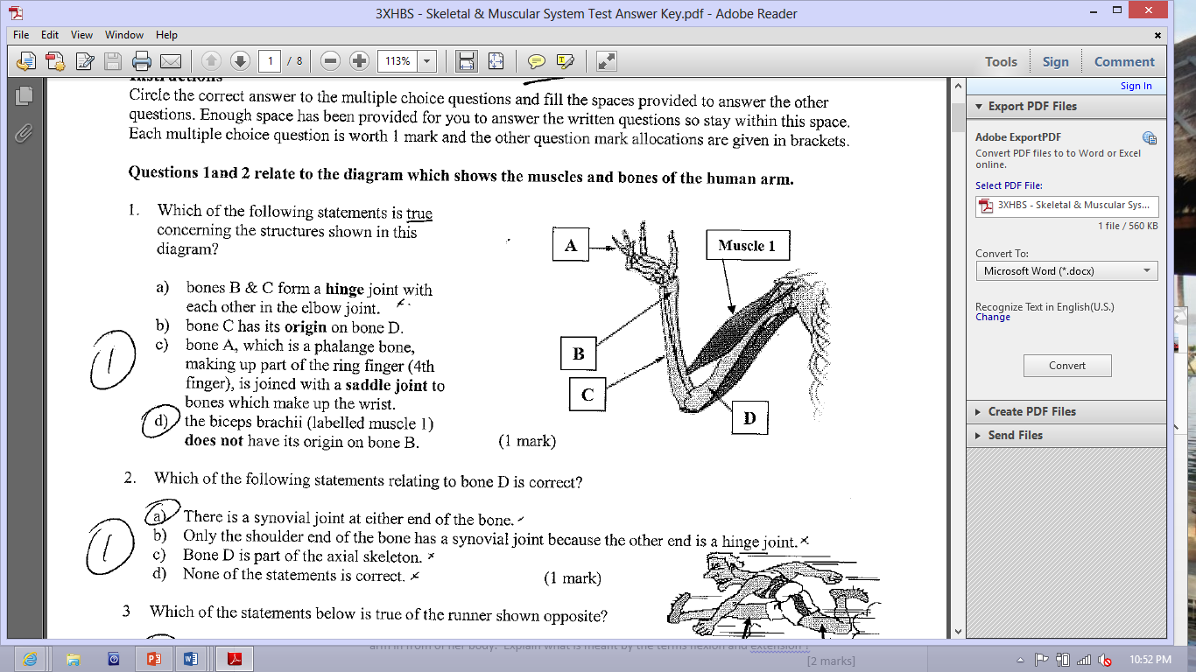

1. Which of the following statement is true concerning the structures shown in this diagram ?
2. Bones B & C form a hinge joint with each other in the elbow joint
3. Bone C has its origin on bone D
4. Bone A, which is a phalange bone, making up part of the ring finger) is joined with a saddle joint to bones which make up the wrist
5. The biceps (labelled muscle 1) does not have its origin on bone B
6. 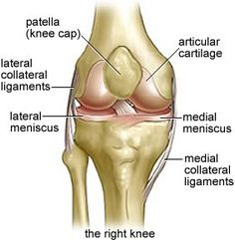A common sports injury suffered by sportsmen is the rupturing of the cruciate ligament in a knee joint. In the diagram, the posterior cruciate ligament (PCL) has been torn and the knee will need to be reconstructed. In this diagram, several structures have been labelled A, B, C and D. Which of the following statements is correct?

C

A

B

1. Structure C is cartilage

D

1. Structure A between C and D is a bursa
2. Structure C is a ligament as it holds B and D together
3. B and D from a pivot joint
4. Which of the following is not an example of a synovial joint?

a. The knee.

b. The cranium.

c. The thumb and palm.

d. The elbow.

Question 4 refers to the diagram of the functional unit of skeletal muscle shown below



1. During muscle contraction:
2. structure C decreases in length.
3. the distance represented by A lengthens.
4. structure D increases in length.
5. the distance represented by B shortens.
6. A bursa is:

a. part of a bone

b. part of the pelvis

c. a sac of fluid often found between tendons and bone

d. connective tissue found in muscles.

1. Which of the following describes the direction of blood flow through the kidney?
2. renal artery, renal vein, afferent arteriole, efferent arteriole, peritubular capillaries.
3. renal vein, renal artery, afferent arteriole, efferent arteriole, peritubular capillaries.
4. renal artery, efferent arteriole, afferent arteriole, peritubular capillaries, renal vein.
5. renal artery, afferent arteriole, efferent arteriole, peritubular capillaries, renal vein.

The table below shows the normal % composition of some components of blood plasma, fluid in the Bowman’s capsule and urine.

|  |  |  |  |
| --- | --- | --- | --- |
| **Component** | **Blood plasma** | **Bowman’s capsule** | **Urine** |
| **Urea** | 0.03 | 0.03 | 2.00 |
| **Uric acid** | 0.004 | 0.004 | 0.05 |
| **Glucose** | 0.10 | 0.10 | None |
| **Amino acids** | 0.05 | 0.05 | None |
| **Minerals** | 0.72 | 0.72 | 1.50 |
| **Proteins** | 8.00 | none | none |

1. Why is there a large amount of protein found in the blood but none in the capsule or urine?
2. The proteins are converted to amino acids before they enter the capsule.
3. The proteins are too large to move through the capsule membrane.
4. The proteins are needed by the body and so are not filtered.
5. The proteins are converted by the capsule into amino acids.
6. Which of the following is NOT a function of saliva?
7. Initial digestion of proteins.
8. Lubrication of the mouth.
9. Initial digestion of carbohydrates.
10. Lubrication of food.
11. Deamination is a metabolic process that involves:
12. carbohydrates under the influence of insulin.
13. fats in the kidney.
14. proteins in the liver.
15. vitamins in the adrenal medulla.
16. What is the role of the kidney in the excretory system of mammals?
17. To remove nitrogenous waste from the body and maintain water levels in the body.
18. To remove salt from the body and to keep water in the body.
19. To remove water from the body and keep salt in the body.
20. To remove water from the body and maintain levels of nitrogenous substances in the body.

**Short Answer Section (34 marks)**

1. [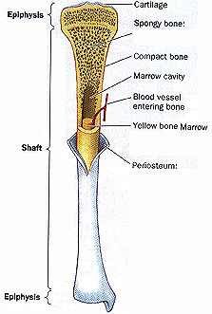](http://www.physioweb.org/skeletal/bone_tissue.html)
2. Describe two major differences between the spongy bone and the compact bone. *(2 marks)*

___________________________________________________________________________________________________________________________________________________________________________________________________________________________________________________________________________________________________________________________________________________

1. Explain why the average age of any bone in an adult is no more than 10 years old. (*2 marks)*

____________________________________________________________________________________________________________________________________________________________________________________________________________________________________________________________________________________________________________________________________________________

1. (a) Name the three types of muscle that can be found in the body. *(1 mark)*

_________________________________________________________________________

(b) Label the diagram below to show the structures found inside a muscle. *(3 marks)*

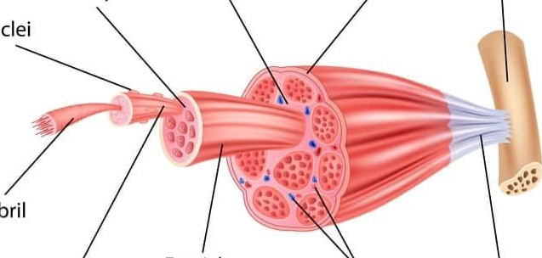

Nuclei

Blood vessels

1. Describe the functions of ligaments. *(1 mark)*

__________________________________________________________________________________________________________________________________________________________________________________

1. Vertebrae in the human body are joined by cartilaginous joints.
2. Name the type of cartilage that is found between vertebrae. *(1 mark)*

_____________________________________________________________________________________

1. Describe how the structure of cartilage referred to in part (i) suits its function. *(2 marks)*

_____________________________________________________________________________________

_____________________________________________________________________________________

_____________________________________________________________________________________

1. Complete the table below, summarising chemical digestion in the alimentary canal. *(3 marks*)

|  |  |  |  |
| --- | --- | --- | --- |
| **Dietary Nutrient** | **Enzyme** | **Nutrient to be absorbed** | **What part/s of the alimentary canal does this chemical digestion occur in?** |
| Carbohydrate |  |  |  |
|  | Lipase |  |  |

1. Enzymes are added in the mouth to break down food. The same enzyme then has to be added again once the food has passed through the stomach. Explain, in detail, why this is necessary.

*(3 marks)*

________________________________________________________________________________________________________________________________________________________________________________________________________________________________________________________________________________________________________________________________________________________________________________________________________________________________________________________

1. Explain why mechanical digestion is a vital part of the digestion process? *(2 marks)*

________________________________________________________________________________________________________________________________________________________________________________________________________________________________________________________________________

1. Cystic Fibrosis is a genetic condition that results in the person producing excessive amounts of mucus. This thick, sticky mucus accumulates on the mucus linings of the digestive.

Explain how this condition would affect the functioning of the small intestine and consequently the health of the Cystic Fibrosis sufferer. *(3 marks)*

*_______________________________________________________________________________*_________________________________________________________________________________________________________________________________________________________________________________________________________________________________________________________________________________________________________________________________________________________________________

1. (a) Name two organs in the body that take part in excretion besides the liver and the kidney.

*(2 marks)*

_____________________________________________________________________________________

(b) Refer to the diagram below of the kidney nephron and associated blood vessels.

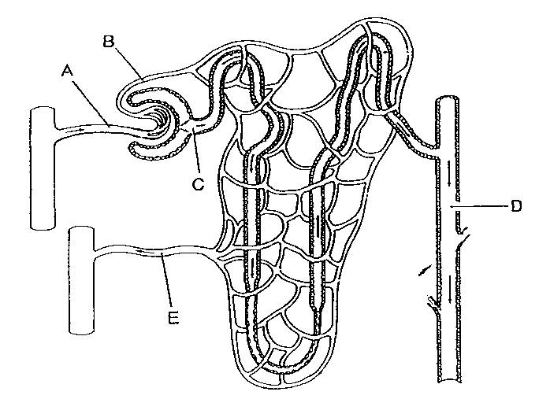

Outline three reasons why the nephron is suited to its function. *(3 marks)*

___________________________________________________________________________________________________________________________________________________________________________________________________________________________________________________________________________

__________________________________________________________________________________________________________________________________________________________________________________

(c) Where do tubular secretions take place in the nephron and explain their purpose? *(2 marks)*

Place : ___________________________________________________________________________________

Purpose : ________________________________________________________________________________

________________________________________________________________________________________

________________________________________________________________________________________

________________________________________________________________________________________

(d) Whilst at the doctor, Bob had his urine tested and it was found that he had high amounts of protein present in his urine sample. Explain why the doctor would be concerned about Bob’s health after reading this information. *(2 marks)*

___________________________________________________________________________________________________________________________________________________________________________________________________________________________________________________________________________

1. Urea is a toxic waste product that is produced by normal processes in the human body. Explain how urea comes to be present in the body. *(2 marks)*

____________________________________________________________________________________________________________________________________________________________________________________________________________________________________________________________________________________________________________________________________________________________________________________________________________________________________________________________

**Extended Response Question (6 marks)**

1. After eating a piece of steak, the body carries out a series of processes to break the protein down. Explain, in detail, the process of digesting protein.

______________________________________________________________________________________________________________________________________________________________________________________________________________________________________________________________________________________________________________________________________________________________________________________________________________________________________________________________________________________________________________________________________________________________________________________________________________________________________________________________________________________________________________________________________________________________________________________________________________________

______________________________________________________________________________________________________________________________________________________________________________________________________________________________________________________________________________________________________________________________________________________________________________________________________________________________________________________________________________________________________

________________________________________________________________________________________________________________________________________________________________________________

___________________________________________________________________________________________________________________________________________________________________________________________________________________________________________________